# Chapter 3, Exercises

## E.3.1

Using SQL Server Management Studio, create a database called test. Store the database in a file named testdate_a in the directory C:\tmp and allocate 10MB of space to it. Configure the file in which the database is located to grow in increments of 2MB, not to exceed a total of 20MB.

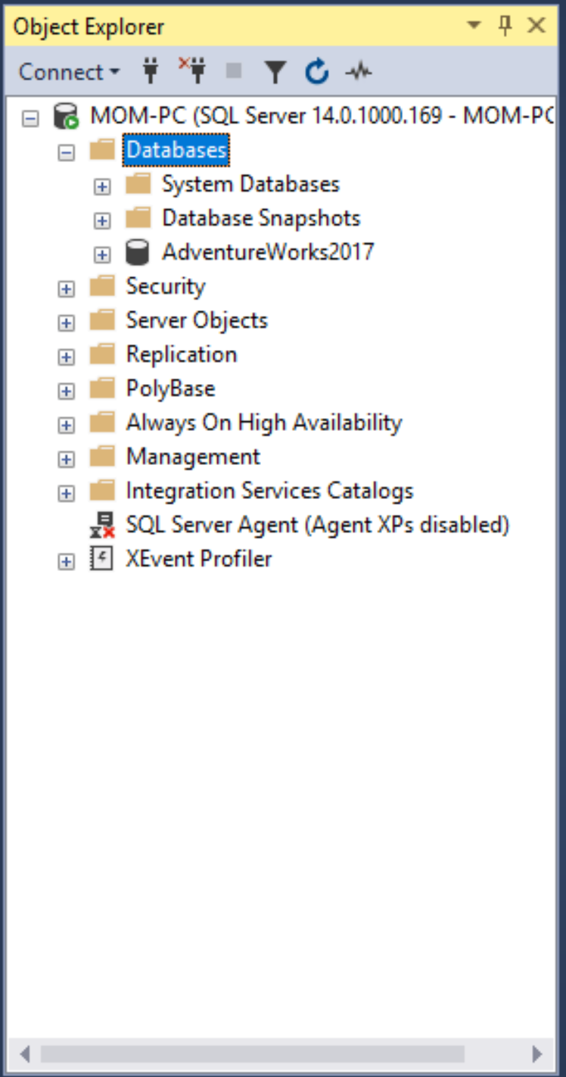The first screenshot contains my Object Explorer before I create the databases from Exercise 3.

The second screenshot is where I stored the database, what I named the file, and the configurations I specified.

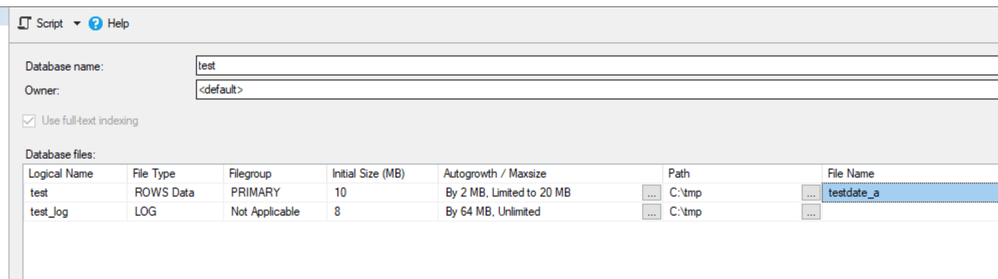

E.3.2

Using SQL Server Management Studio, change the transaction log for the test database. Give the file an initial size of 3MB, with growth of 20 percent. Allow the file for the transaction log to autogrow.

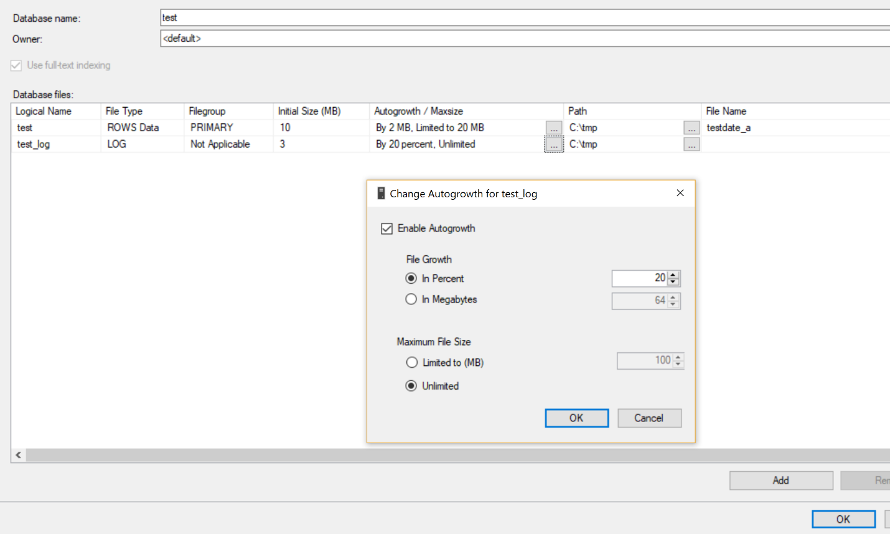Below you can see I changed the specifications of the transaction log of my database, here you can see I allowed Autogrowth.

## E.3.3

Using SQL Server Management Studio, allow only the database owner and system administrator to use the test database. Is it possible that both users could use the database at the same time?

You can see that I restricted access to the database, this allows only the database owner and system administrator to use the database.

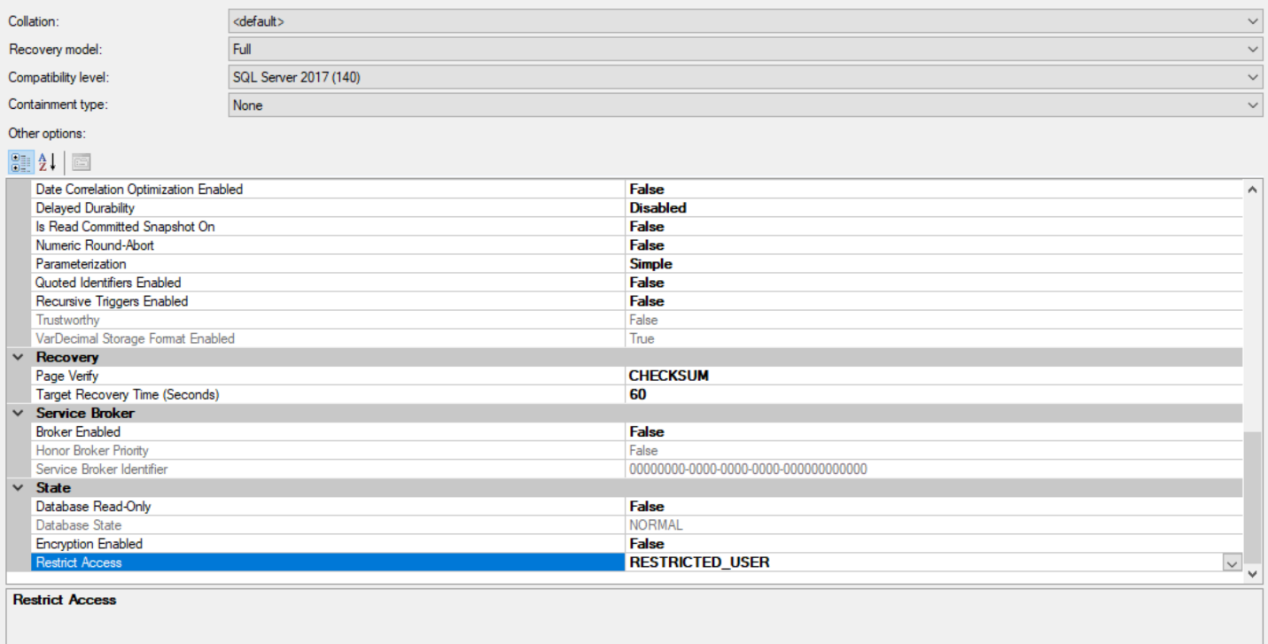It is possible for them to use the database at the same time. If we set the ‘SINGLE_USER’ access, then only one person can use the database at a time.

## E.3.4

Using SQL Server Management Studio, create all four tables of the sample database (see Chapter 1) with all their columns.

In the following screenshots I created the four tables specified. In order: department, employee, project, works_on.

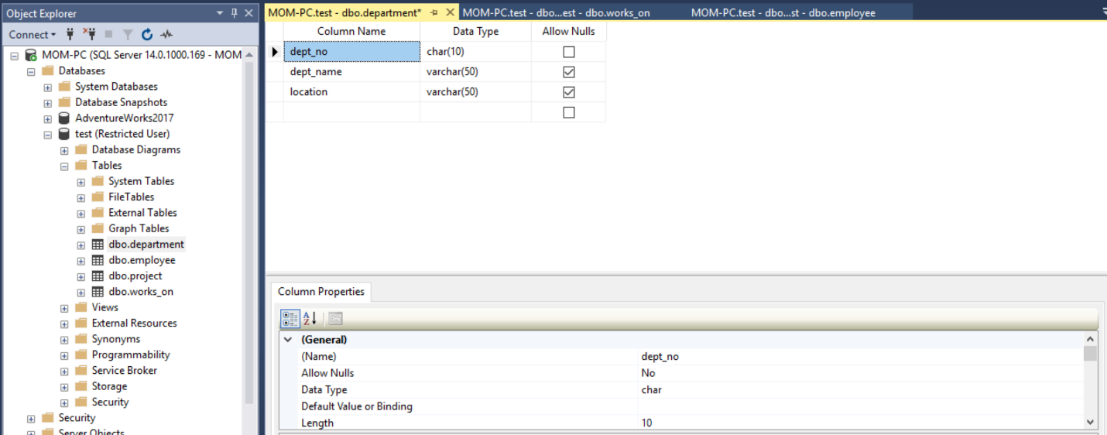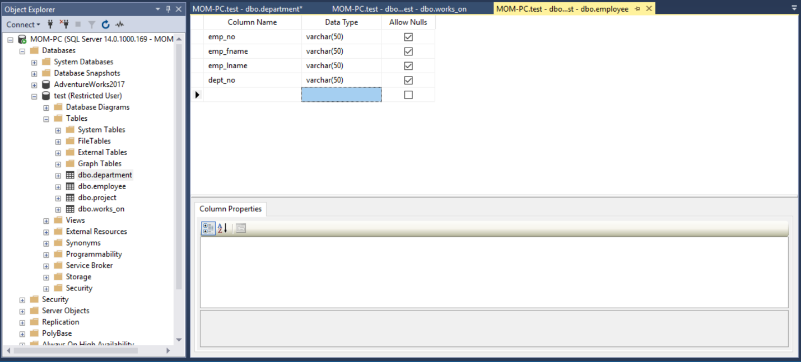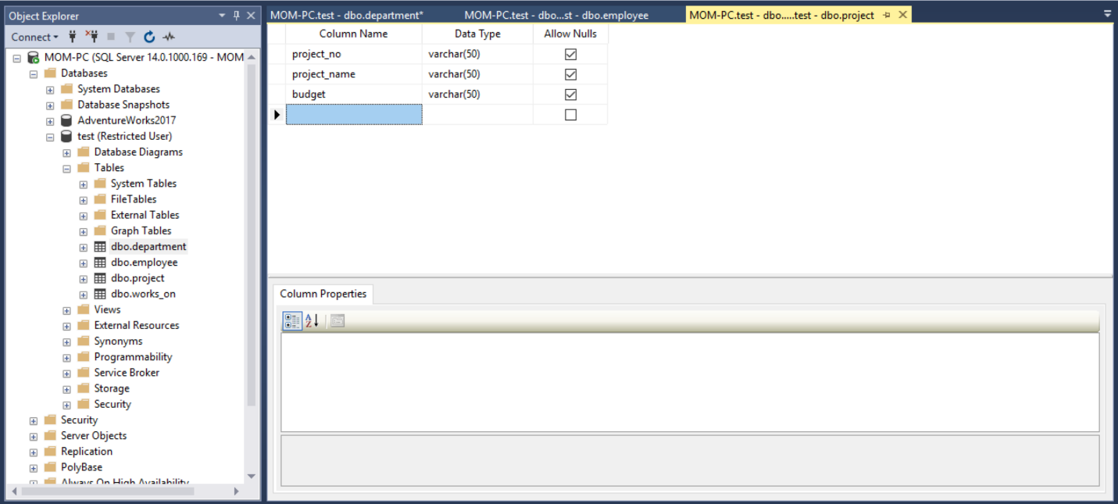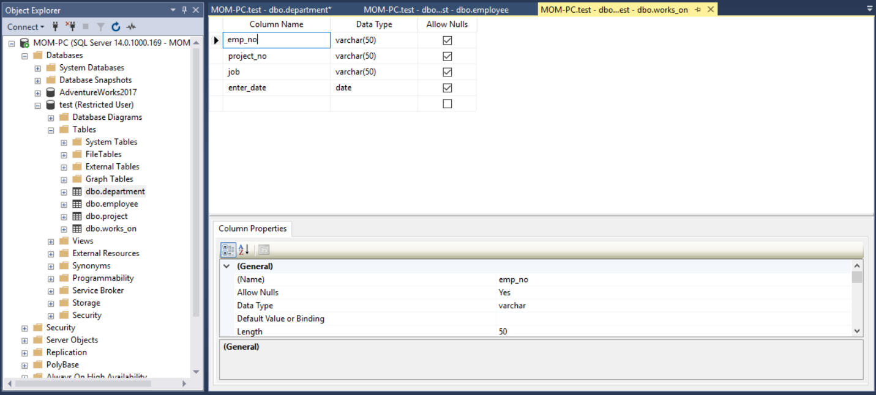

## E.3.5

Using SQL Server Management Studio, view which tables the AdventureWorks database contains. After that, choose the Person.Address table and view its properties.

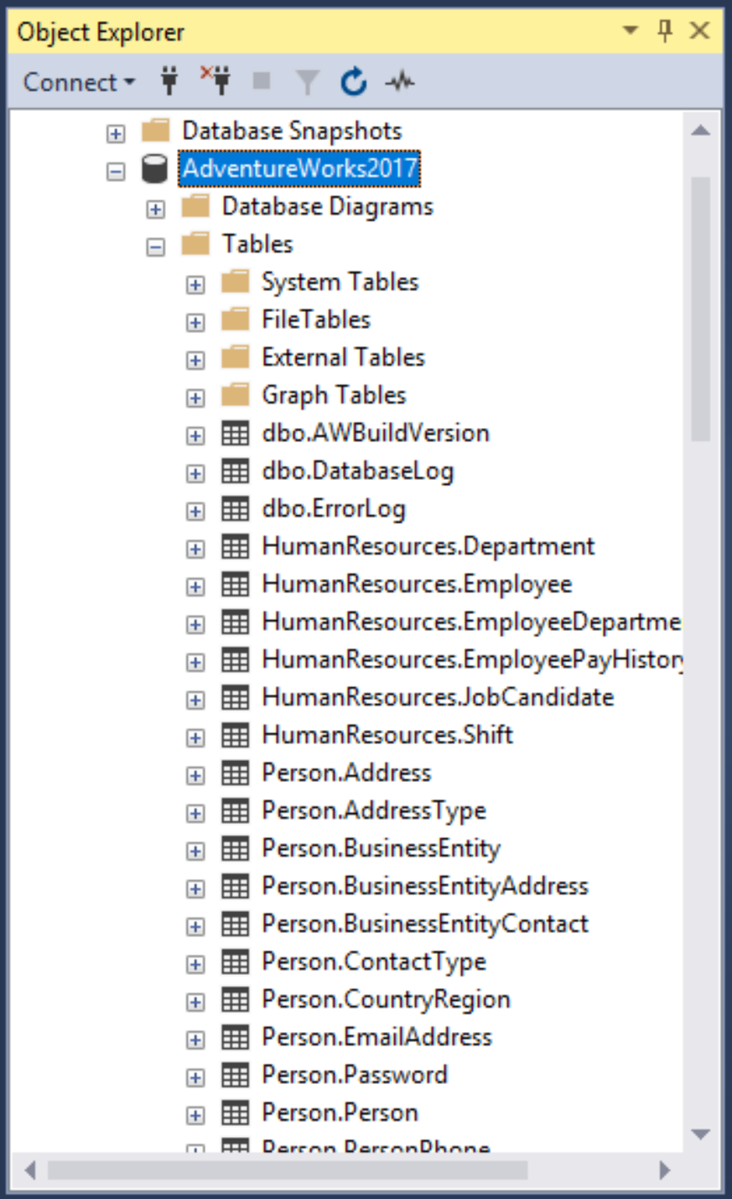The following screenshots are the tables in the AdventureWorks database.

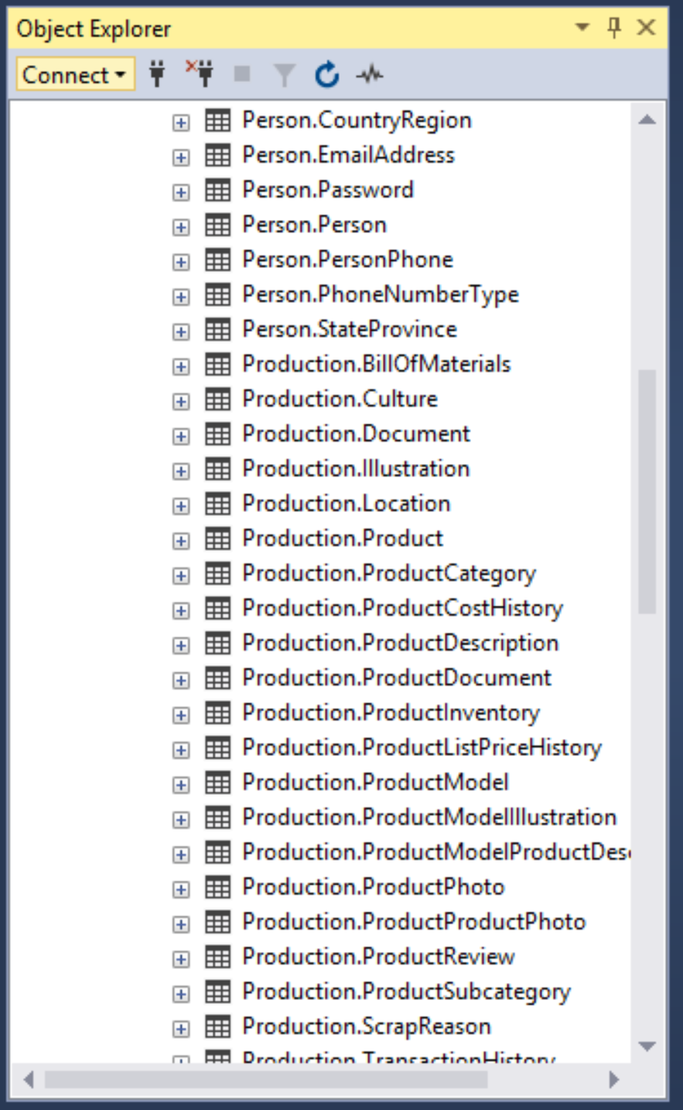

This is the second screenshot of the tables.

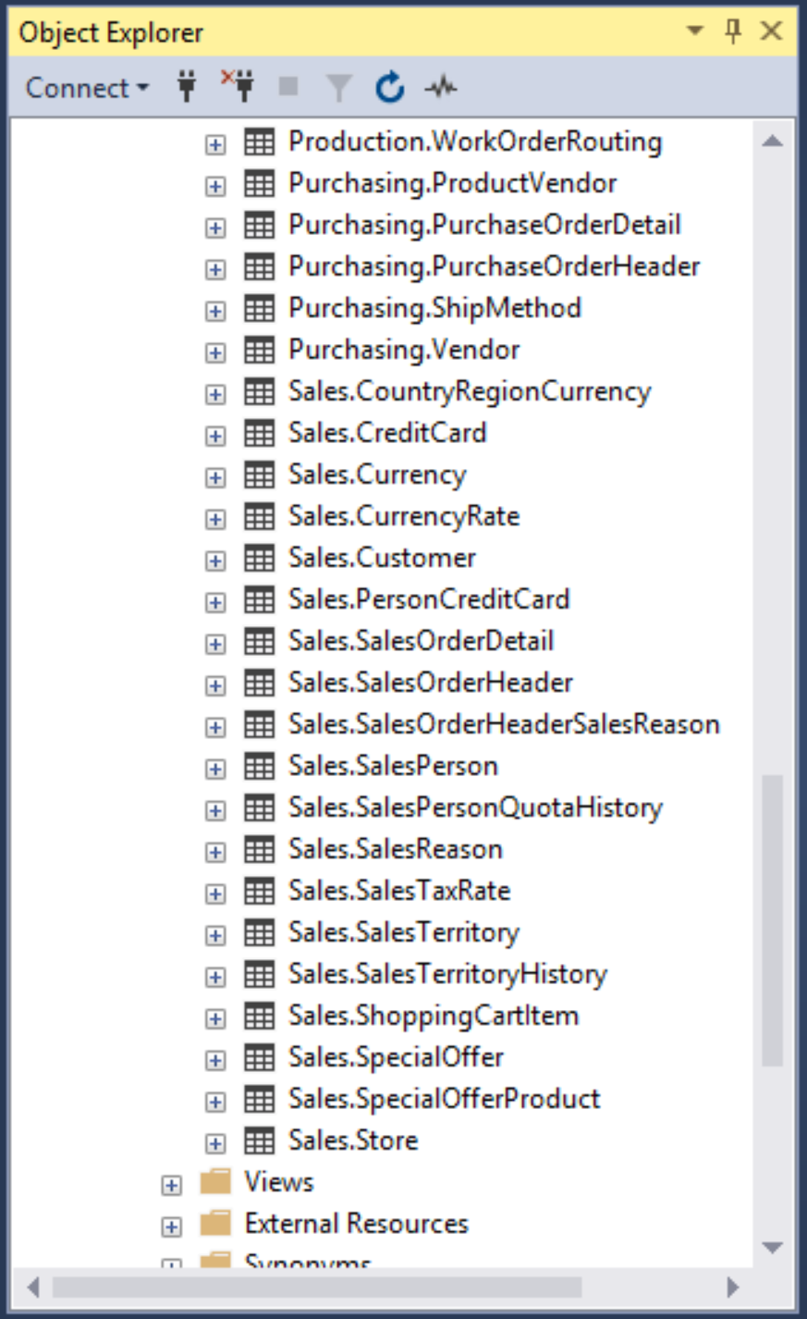 This is the last screenshot of the tables in the Object Explorer.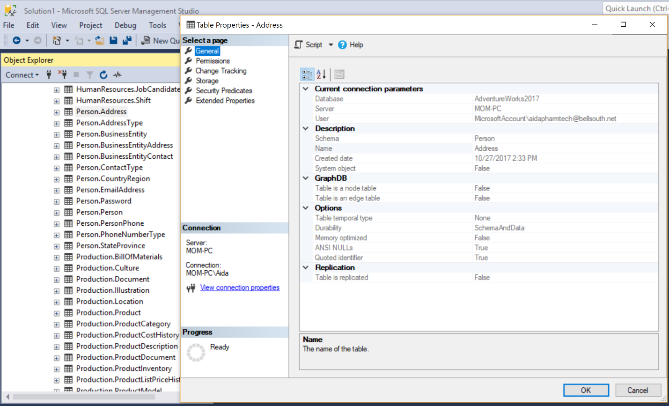

This is a screenshot of the view of the properties of the Person.Address table.

## E.5.1

Using the CREATE DATABASE statement, create a new database named test_db with explicit specifications for database and transaction log files. The database file with the logical name test_db_dat is stored in the file C:\tmp\test_db.mdf and the initial size is 5MB, the maximum size is unlimited, and the file growth is 8 percent. The log file called test_db_log is stored in the file C:\tmp\test_db_log.ldf and the initial size is 2MB, the maximum size is 10MB, and the file growth is 500KB.

**I attached the SQL file to the upload for the next 3 exercises.**

The first screenshot below is the database being created with a query according to the specifications.

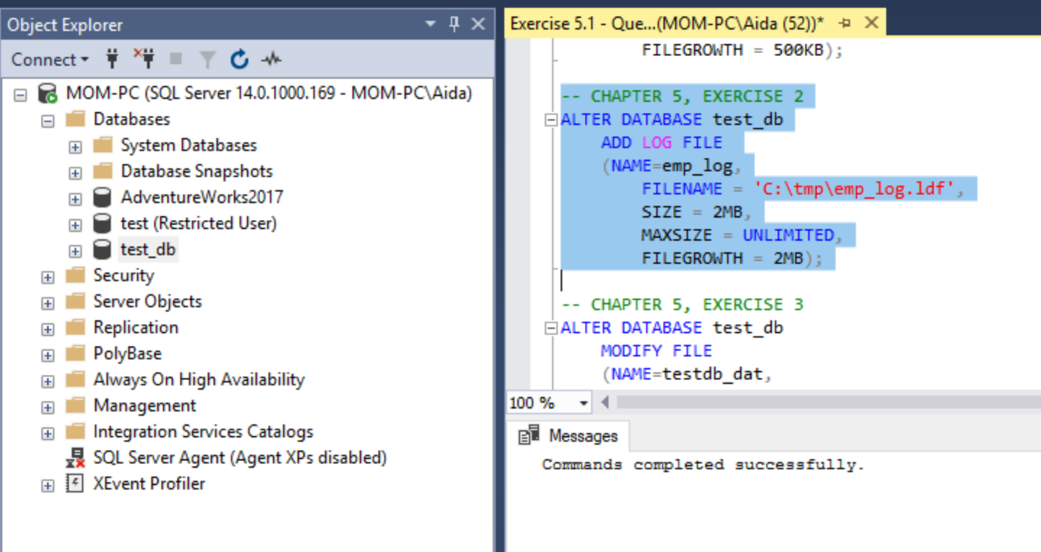

This screenshot shows the properties of the database created, with the specifications.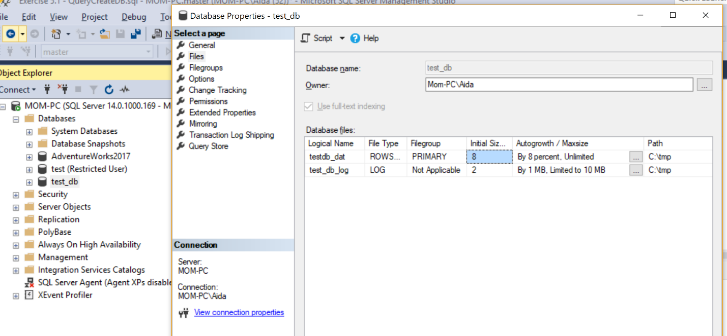

## E.5.2

Using the ALTER DATABASE statement, add a new log file to the test_db database. The log file is stored in the file C:\tmp\emp_log.ldf and the initial size of the file is 2MB, with growth of 2MB and an unlimited maximum size.

The first screenshot contains the query used to create a new log file using the alter statement.



Next screenshot contains the properties of the modified table, you can see the new log file.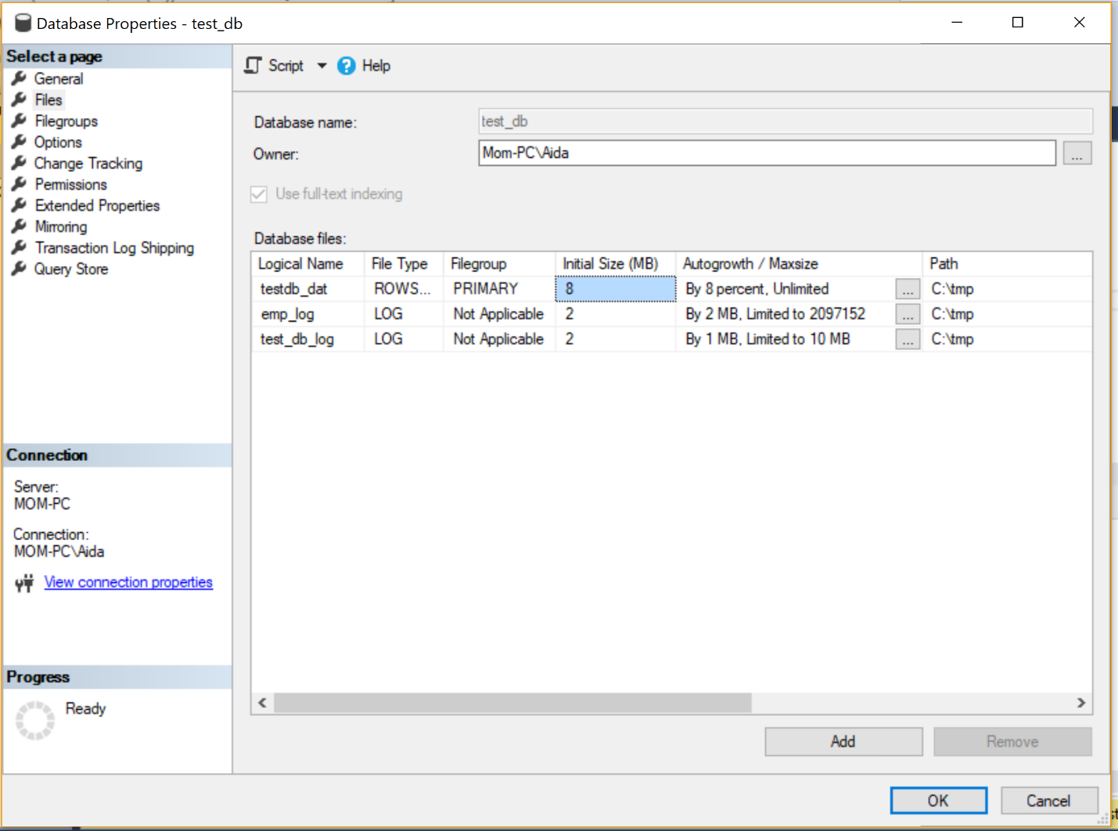

## E.5.3

Using the ALTER DATABASE statement, change the file size of the test_db database to 10MB.

The screenshot contains the query where I modified the size of the database to 10 MB.

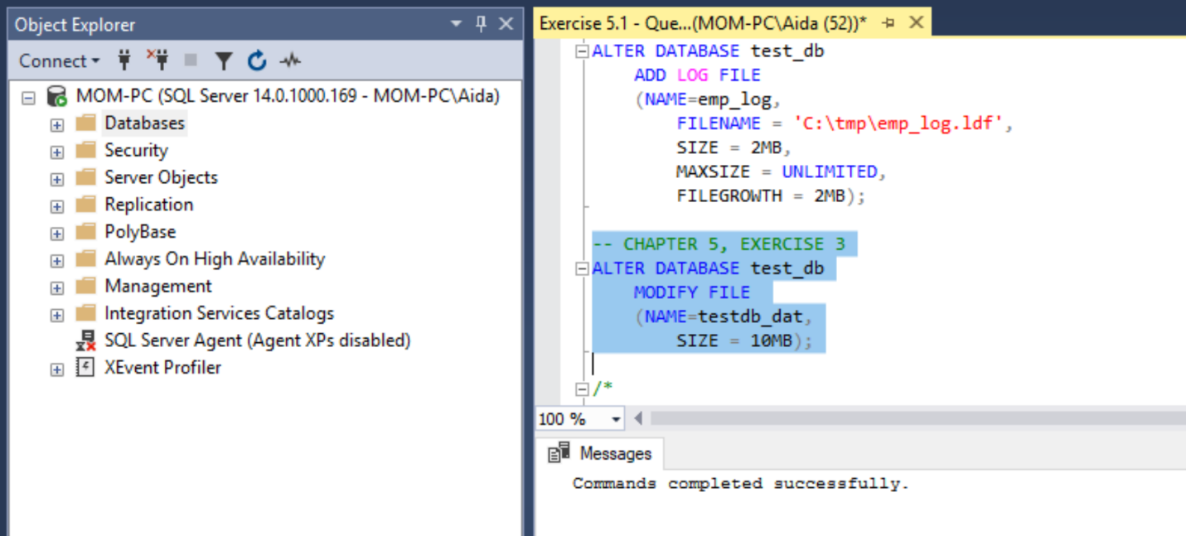

This shows the properties, you can see the initial size is now 10MB.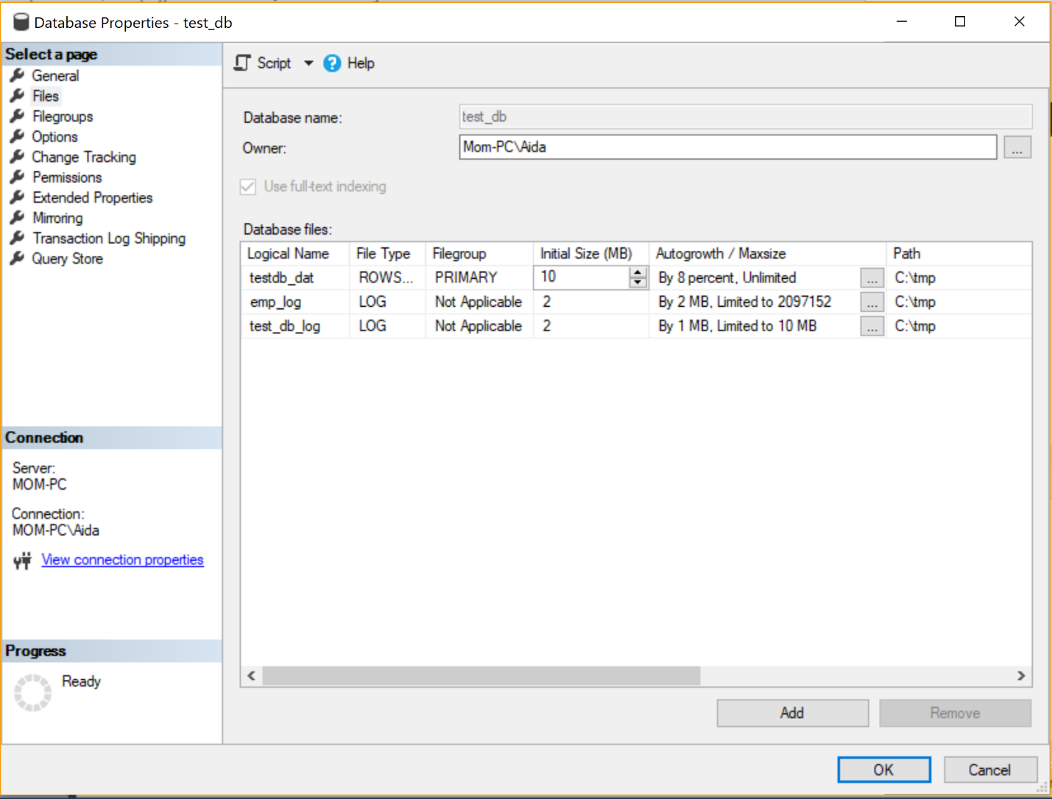

## E.5.4

In Example 5.4, there are some columns of the four created tables defined with the NOT NULL specification. For which column is this specification required and for which is it not required?

In the table Employee, the fields that contain the NOT NULL constraint are emp_no, emp_fname, emp_lname. dept_no is the only field with the NULL constraint.

In the table department, the fields that contain the NOT NULL constraint are dept_no and dept_name. location has the NULL constraint in the table.

In the table project, the fields that contain the NOT NULL constraint are project_no, project_name. The budget field containts the NULL constraint.

In the table works_on, the fields that contain the NOT NULL constraint are emp_no, project_no. job and enter_date are the fields with the NULL constraint.

NOT NULL values required a value to be placed into it, they cannot be left NULL. They are required.

## E.5.5

Why are the columns dept_no and project_no in Example 5.4 defined as CHAR values (and not as numerical values)?

dept_no and project_no are defined as CHAR values because they contain both a alpha character and a numeric character. Character datatype can take both letters and numbers. If I were to use an integer datatype, I would not be able to use a letter in the field.